PROJECT REPORT
Automated Network Request Management
ServiceNow Scoped Application and Network Request Portal
Date: November 2026
Student Name: Rachabathula Gnana Sruthi

Project Documentation

Prepared based on the provided project implementation and reference report structure.
Technology: ServiceNow
Application: Automated Network Request Management
Project: Automated Network Request Management

TABLE OF CONTENTS
1. INTRODUCTION
1.1 Project Overview
1.2 Purpose
2. IDEATION PHASE
2.1 Problem Statement
2.2 Empathy Map Canvas
2.3 Brainstorming
3. REQUIREMENT ANALYSIS
3.1 Customer Journey Map
3.2 Solution Requirements
3.3 Data Flow Diagram
3.4 Technology Stack
4. PROJECT DESIGN
4.1 Problem-Solution Fit
4.2 Proposed Solution
4.3 Solution Architecture
5. PROJECT PLANNING & SCHEDULING
5.1 Project Planning
6. FUNCTIONAL AND PERFORMANCE TESTING
6.1 Performance Testing
7. RESULTS
7.1 Output Screenshots
8. ADVANTAGES & DISADVANTAGES
9. CONCLUSION
10. FUTURE SCOPE
11. APPENDIX

1. INTRODUCTION

1.1 Project Overview
The Employee Raise Issue project is a ServiceNow-based scoped application designed to provide employees with a structured, user-friendly mechanism for submitting workplace IT issues or requests. The solution combines a custom Employee Raise Issue table, Service Catalog item/Record Producer, dependent choice fields, UI Policies, a dedicated Service Portal, and custom widgets.
The implementation provides a controlled path from employee interaction through the portal to creation of a backend issue record. It reduces unstructured issue reporting, improves data consistency, and provides a foundation for efficient issue assignment, tracking, and resolution.

1.2 Purpose
- Provide a standardized mechanism for employees to raise IT-related issues.
- Capture issue information in a structured backend table.
- Guide employees through relevant Category and Subcategory selections.
- Enforce field behavior and mandatory information using UI Policies.
- Provide a dedicated portal experience with custom interactive widgets.
- Connect the portal submission experience with the Employee Raise Issue backend record.

2. IDEATION PHASE

2.1 Problem Statement
Employees may need to report network, hardware, software, access, or related support issues. Without a standardized intake mechanism, issue information can be incomplete or inconsistent, making categorization, assignment, and follow-up more difficult. The project addresses this problem by providing a guided ServiceNow portal-based issue submission process.

2.2 Empathy Map Canvas
Perspective | Project Interpretation
Says | I need a simple way to report an issue and provide the necessary details.
Thinks | I want to know that my request was submitted correctly and routed appropriately.
Does | Logs into the employee portal, selects an issue category, enters a description, and submits the request.
Feels | Expects a quick, clear, and reliable support experience.
Pain Points | Unstructured requests, irrelevant choices, missing descriptions, and unclear submission flow.
Needs | A guided form, controlled choices, clear navigation, and consistent record creation.

2.3 Brainstorming
- Create a scoped ServiceNow application for employee issue management.
- Create a custom table with structured issue fields.
- Use a Service Catalog item and Record Producer for guided submission.
- Use dependent Category/Subcategory choices to prevent irrelevant selections.
- Use UI Policies to make required fields mandatory under appropriate conditions.
- Provide a dedicated Service Portal and customized Employee Center homepage.
- Use custom widgets for a visually engaging portal and direct issue-raising navigation.

3. REQUIREMENT ANALYSIS

3.1 Customer Journey Map
Stage | Employee Action | System Response | Expected Outcome
Access | Open Requesting Portal | Loads Employee Center homepage | Employee can access services
Discover | Scroll/search portal | Displays custom widgets and navigation | Employee finds Raise an Issue
Raise | Click Raise Ticket | Redirects to Record Producer | Issue form opens
Enter | Provide requester, category, subcategory and description | Applies field rules and dependencies | Valid data is captured
Submit | Click Submit | Creates Employee Raise Issue record | Issue is registered
Follow-up | Issue is processed | State/priority/assignment information supports handling | Issue can be managed to resolution

3.2 Solution Requirements

Functional Requirements
FR No. | Functional Requirement | Sub-Requirement / Expected Behavior
FR-1 | Application setup | Create scoped application named Employee Center.
FR-2 | Issue record creation | Create Employee Raise Issue custom table with auto-number.
FR-3 | Issue data capture | Capture requester, category, subcategory, short description, state, priority and assignment group.
FR-4 | Controlled choices | Display relevant subcategories based on selected category.
FR-5 | Dynamic field validation | Make Short Description mandatory when State is New.
FR-6 | Record integrity | Keep Number field read-only.
FR-7 | Catalog submission | Provide Raise Employee Issue catalog item with mapped variables.
FR-8 | Portal access | Provide Requesting Portal and Employee Center homepage.
FR-9 | Widget navigation | Allow Raise Ticket widget to redirect to the Record Producer.
FR-10 | Testing | Validate portal navigation, submission and configured field restrictions.

Non-Functional Requirements
NFR No. | Requirement | Description
NFR-1 | Usability | Simple guided portal experience for employees.
NFR-2 | Data Consistency | Controlled choices and mapped variables reduce inconsistent entries.
NFR-3 | Reliability | Configuration should consistently create the intended backend record.
NFR-4 | Maintainability | ServiceNow configuration is separated into tables, policies, catalog items and widgets.
NFR-5 | Security | Use ServiceNow platform access controls and scoped application boundaries.
NFR-6 | Performance | Portal widgets and navigation should provide a responsive user experience.

3.3 Data Flow Diagram
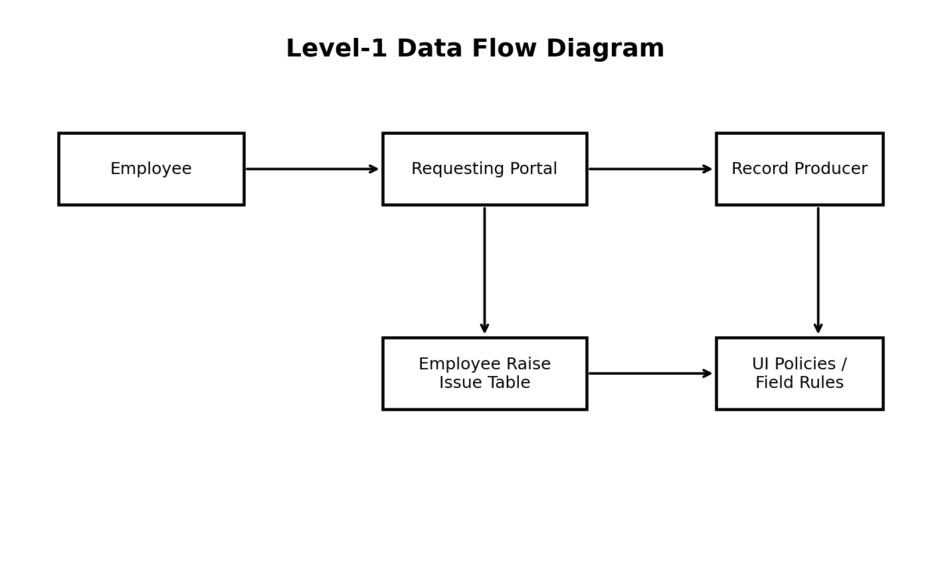
Figure 1: High-level flow from employee portal submission to backend issue record.

3.4 Technology Stack
Component | Technology / Configuration | Purpose
Platform | ServiceNow | Application platform and service management environment.
Application | Employee Center scoped application | Container for the custom solution.
Data Layer | Employee Raise Issue custom table | Stores submitted issue information.
Service Catalog | Raise Employee Issue | Provides guided issue submission.
Record Producer | Raise Employee Issue flow | Creates/submits the backend issue record from the portal experience.
Portal | Service Portal / Requesting Portal | Employee-facing interface.
Portal Design | Employee Center Homepage | Existing page customized with widgets.
Widget UI | HTML, CSS | Custom portal presentation and animation.
Client Logic | Service Portal Client Script / AngularJS | Redirects the user to the configured Record Producer.
Configuration | UI Policies / Dictionary dependency | Controls field behavior and dependent choices.

4. PROJECT DESIGN

4.1 Problem-Solution Fit
Parameter | Project Fit
Problem | Employees need a consistent and simple way to submit workplace IT issues.
Solution | A ServiceNow Employee Raise Issue application with portal-based submission.
Customer Benefit | Guided issue entry, controlled choices and clearer submission flow.
Operational Benefit | Structured backend records support categorization and issue handling.
Uniqueness | Combines ServiceNow configuration with a dedicated portal and custom interactive widgets.
Scalability | Additional issue fields, categories, assignment logic, notifications and reporting can be added later.

4.2 Proposed Solution
The proposed solution is a scoped ServiceNow application named Employee Center. A custom Employee Raise Issue table stores issue records. A Raise Employee Issue Service Catalog item provides variables mapped to the table. A Requesting Portal and customized Employee Center homepage expose the functionality to employees. UI Policies and dependent choices enforce appropriate form behavior, while custom widgets improve navigation and presentation.

4.3 Solution Architecture
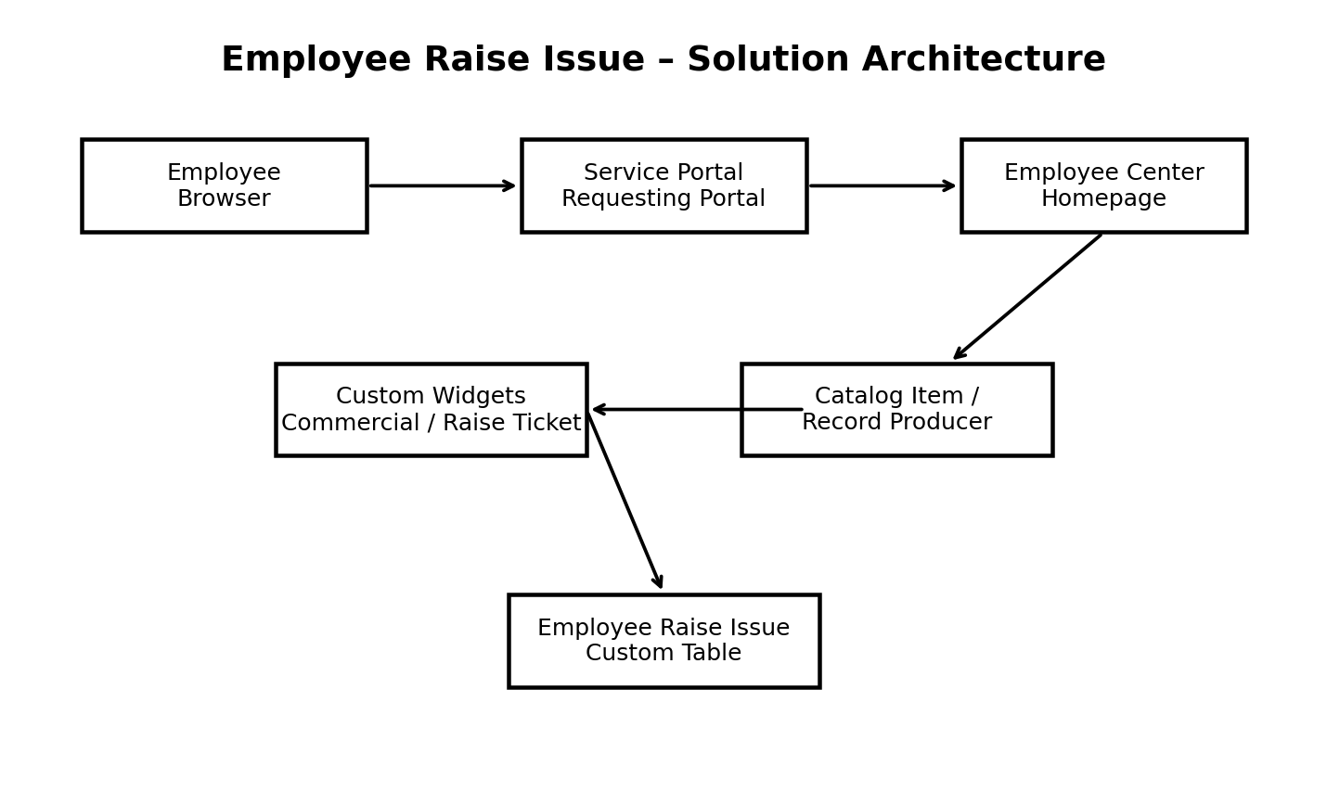
Figure 2: Employee Raise Issue solution architecture.

Core Data Model
Field | Type | Configuration / Values
Number | Auto Number | Automatically generated issue identifier.
Requester | Reference | sys_user table.
Category | Choice | Network, Hardware, Software, Access.
Subcategory | Choice | VPN, Laptop, Server, Forgot password; dependent on Category.
Short Description | String | Issue summary; mandatory when State is New.
State | Choice | New, In Progress, Resolved, Closed.
Priority | Choice | Critical, High, Medium, Low.
Assignment Group | Reference | sys_user_group table.

Category / Subcategory Dependency
Category | Subcategory
Network | VPN
Hardware | Laptop
Software | Server
Access | Forgot password

5. PROJECT PLANNING & SCHEDULING

5.1 Project Planning
The implementation can be organized into short iterative work packages so that the core application is established first and the portal experience is added afterward.
Phase / Sprint | Major Tasks | Deliverable
Sprint 1 – Foundation | Create scoped application; create Employee Raise Issue table; configure fields and auto-number. | Working application and data model.
Sprint 2 – Rules | Configure UI Policies; configure Category/Subcategory dependency; validate field behavior. | Validated form rules and controlled choices.
Sprint 3 – Service Catalog | Create Raise Employee Issue catalog item; create and map variables; configure Record Producer navigation. | Guided issue submission.
Sprint 4 – Portal | Create Requesting Portal; customize Employee Center homepage; create Commercial and Link Redirect widgets. | Employee-facing portal experience.
Sprint 5 – Testing | Test navigation, widget behavior, Record Producer, field restrictions and submission. | Validated end-to-end solution.

Project Tracker
Work Item | Status | Validation
Scoped application | Completed | Employee Center created and selected as current application.
Custom table | Completed | Employee Raise Issue table created.
Fields | Completed | Required fields configured.
UI Policies | Completed | Short Description mandatory for New; Number read-only.
Dependent choices | Completed | Category controls Subcategory.
Catalog item | Completed | Raise Employee Issue created with mapped variables.
Portal | Completed | Requesting Portal configured.
Custom widgets | Completed | Commercial and Link Redirect widgets created.
Testing | Completed | Portal navigation and issue submission validated.

6. FUNCTIONAL AND PERFORMANCE TESTING

6.1 Performance Testing
Testing focused on functional correctness and user interaction rather than load benchmarking. The implemented portal was exercised through the configured Service Portal URL, and the issue-raising flow was validated from widget interaction through Record Producer submission.
Test ID | Test Scenario | Expected Result | Status
TC-01 | Open Requesting Portal | Portal loads and configured branding/images are visible. | Pass
TC-02 | View homepage widgets | Commercial and Raise Ticket widgets appear in configured positions. | Pass
TC-03 | Hover over widgets | Floating/hover animations are visible. | Pass
TC-04 | Click Raise Ticket | User is redirected to the configured Record Producer. | Pass
TC-05 | Category selection | Category choices are displayed correctly. | Pass
TC-06 | Dependent Subcategory | Only relevant Subcategory is available for the selected Category. | Pass
TC-07 | State = New | Short Description becomes mandatory. | Pass
TC-08 | Number field | Number remains read-only. | Pass
TC-09 | Submit issue | Issue details are submitted and backend record is created. | Pass
TC-10 | End-to-end flow | Portal-to-record process completes without functional interruption. | Pass

Performance note: the project was validated for normal portal interaction and response behavior. Formal concurrent-user/load testing was not part of the supplied implementation evidence.

7. RESULTS

7.1 Output Screenshots
The reference implementation includes portal and widget testing. Actual screenshots were not included with the supplied project description, so the following locations are reserved for project screenshots.
Figure | Recommended Screenshot
Figure 3 | Requesting Portal homepage showing configured logo/image and navigation.
Figure 4 | Employee Center homepage with Commercial Widget.
Figure 5 | Raise Ticket / Link Redirect widget with hover effect.
Figure 6 | Raise Employee Issue Record Producer.
Figure 7 | Category and dependent Subcategory fields.
Figure 8 | State = New with Short Description shown as mandatory.
Figure 9 | Number field shown as read-only.
Figure 10 | Submitted Employee Raise Issue backend record.

8. ADVANTAGES & DISADVANTAGES

Advantages
- Standardizes employee issue submission.
- Improves data quality through structured fields and dependent choices.
- Reduces irrelevant Category/Subcategory combinations.
- Automatically generates issue numbers.
- Enforces mandatory and read-only field behavior using UI Policies.
- Provides a dedicated employee-facing portal.
- Offers direct navigation from a custom widget to the issue Record Producer.
- Provides a scalable ServiceNow foundation for future workflow and reporting enhancements.

Disadvantages / Current Limitations
- The supplied implementation does not document advanced assignment automation or notification workflows.
- Formal load/performance benchmarking with concurrent users was not provided.
- Portal screenshots and production deployment evidence were not supplied.
- Additional controls may be required before production use, depending on organizational security and access requirements.

9. CONCLUSION
By implementing a custom scoped application, custom table, UI Policies, dependent choices, Service Catalog/Record Producer, and a dedicated Service Portal, the Employee Raise Issue solution provides a structured mechanism for employees to report workplace IT issues.
The solution standardizes issue submission, enforces business rules through UI Policies, controls category and subcategory selection, and connects the employee-facing portal with backend ServiceNow records. End-to-end validation confirmed the intended navigation, widget behavior, field restrictions, and issue submission flow.
Overall, the implementation reduces manual effort and data inconsistencies while improving the employee experience for raising and managing support issues.

10. FUTURE SCOPE
- Automated assignment of issues to groups based on Category, Subcategory or Priority.
- Email and ServiceNow notifications for submission, assignment, status changes and resolution.
- Approval or escalation workflows for selected issue types.
- Employee-facing issue tracking and status history.
- Reports and dashboards for issue volume, priority, category and resolution time.
- Attachment support for screenshots and supporting evidence.
- Additional dependent categories and subcategories.
- Role-based access and more granular security controls.
- Knowledge article recommendations before an employee submits a ticket.
- Formal performance testing and monitoring under concurrent user load.

11. APPENDIX

A. Application Creation
- Navigate to All menus → App Engine → ServiceNow Studio.
- Select Create → App.
- Set Name to Employee Center and Scope to Scoped.
- Continue, return to the home screen, reload, and confirm Employee Center is the current application.

B. Table and Field Configuration
- Navigate to Tables under System Definition and select New.
- Set Label to Employee raises issue and enable Auto number.
- Open the form and use Configure → Form Design to add the required fields.
- Configure reference fields to sys_user and sys_user_group where applicable.
- Configure Category and Subcategory as choice fields and define the required choices.

C. UI Policies
Policy | Condition | Action
Short Description Mandatory | State is New | Short description Mandatory = True.
Number Read Only | No filter condition | Number Read only = True.

D. Service Catalog Item and Variables
Variable | Type | Mapped Field
Requester | Reference | Requester / sys_user
Category | Choice | Category
Subcategory | Choice | Subcategory
State | Choice | State
Short description | Single Line Text | Short description

E. Custom Widget – Commercial Widget
The widget uses HTML and CSS to display a service-information card with gradient styling, hover movement, floating text, animated glow, and staggered list-item animations.
<div class="commercial-widget">
<h2>Our Commercial Services</h2>
<p>
We provide end-to-end IT services, support, and issue resolution
through a streamlined Service Portal experience.
</p>
<ul>
<li>✔ 24/7 Customer Support</li>
<li>✔ Faster Issue Resolution</li>
<li>✔ Transparent Tracking</li>
<li>✔ Secure & Reliable</li>
</ul>
</div>

F. Custom Widget – Link Redirect / Raise Ticket
The widget provides an interactive Raise an Issue card. Its Client Script redirects the user to the configured Record Producer using its sys_id.
function ($scope, $location) {
var c = this;
var RECORD_PRODUCER_SYS_ID = 'ae2cd61183433210de6fc590ceaad3a4';
c.openRecordProducer = function () {
$location.url(
'sp?id=sc_cat_item&sys_id=' + RECORD_PRODUCER_SYS_ID
);
};
}

G. Service Portal Configuration
Property | Configured Value
Title | Requesting Portal
URL suffix | employee_request
Homepage | ec_standard_home
Knowledge Base home page | esc_knowledge_home
Login page | login
Main menu | Employee Center Menu
404 page | 404
Theme | Employee Center Coral Theme
Logo | Uploaded project image

H. Project Outcome
The final implementation provides standardized issue submission, controlled field behavior, dependent selections, portal-based navigation, custom widgets, and a connected ServiceNow backend record structure.

